4.2 Double Integrals over Nonrectangular Regions

Motivation: We want to be able to integrate two variable functions not just over rectangles but also over regions D of a more general shape.

Suppose we want to integrate the function over a bounded region D. Since D is bounded we know that it can be enclosed in a rectangle. A picture of what D might look like along with a rectangle it is contained in is:

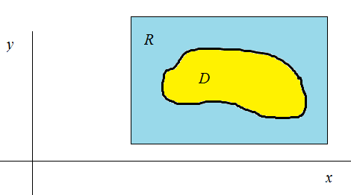

Definition: If is integrable over , then we define the double integral of f over D by (where we are using the notation and symbols introduced in the motivation).

Definition: We say that a plane region D is a
- type 1 region if it lies between the graphs of two continuous functions of x, that is, where and are continuous on .

- type 2 region if it lies between the graphs of two continuous functions of y, that is, where and are continuous on .

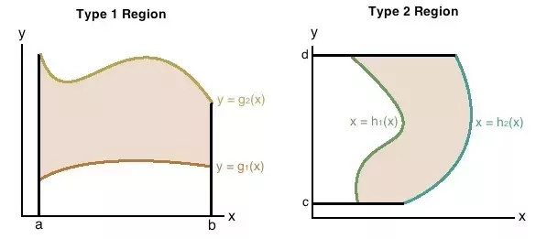

Exploration:
Suppose we wish to evaluate when is a type 1 region and is continuous on D. To do this, we pick a rectangle containing D. A picture of what R might look like is shown below.

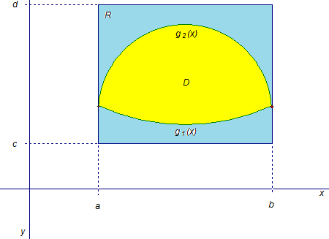

We now summarize the results of the exploration above.

Theorem:
- If is continuous on a type 1 region D such that and both and are continuous on , then .
- If is continuous on a type 2 region D such that and both and are continuous on , then .

Question: Could we interchange the order of the integrals and differentials in the most recent theorem?

Example 1: Find the volume of the solid which is in the first octant and lies under the plane given by: .

Question: Why would it be incorrect to use the iterated integral to find the desired volume in this example?

Example 2: Suppose that D is the region in the xy-plane bounded by and . Use a double integral to find the volume of the solid that lies below the surface given by and above the region D.

Example 3: Evaluate the iterated integral .

Example 4: Evaluate over the region D in the first quadrant which is bounded by the graphs , , and .

Double Integral Properties Over a Region D:

Assume that and exist. Also suppose that c is a constant. Then,
- If for all in D, then
- If where and don’t overlap except perhaps at the boundaries, then .
- If represents the area of D, then .
- If for all , then .

Example 5: Suppose that D is the region in the xy-plane bounded by and . Use a double integral to find the area of D.

